CRM Dashboard-Campaigns: When you click on Campaign from the Dashboard, you will see a list of existing defined campaigns. They could be groups of names for Thank You letters, mailings, equipment schools, open house, and so on.

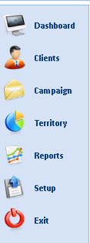

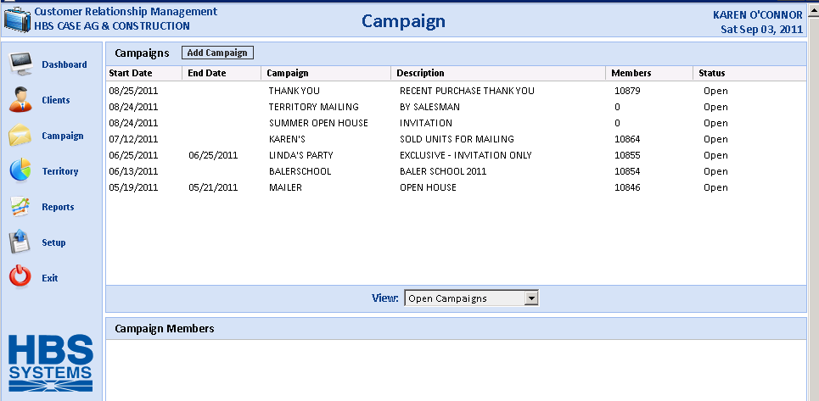

When you select an existing campaign, the bottom of the screen will populate with the members of that campaign.

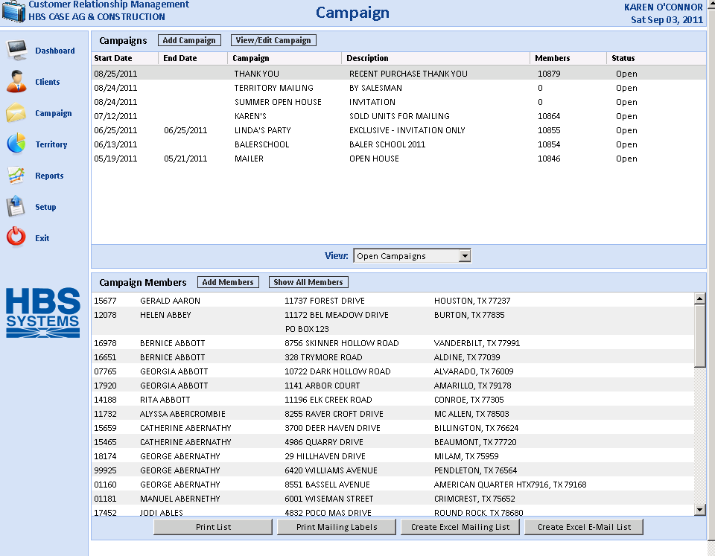

With the member list shown, you can perform the following functions:

Print List: This prints a report to the printer of your choice listing the members of that campaign.

Print Mailing Labels: This generates a set of mailing labels for the members of the campaign. It uses a standard Avery 5160/5260 label size of 3 across labels.

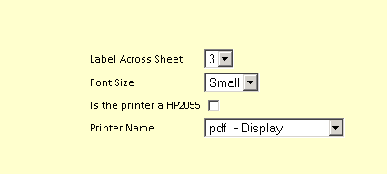

Create Excel mailing List: This produces an Excel spreadsheet of the members of the campaign. This spreadsheet could also feed the Microsoft Mail Merge function in Word.

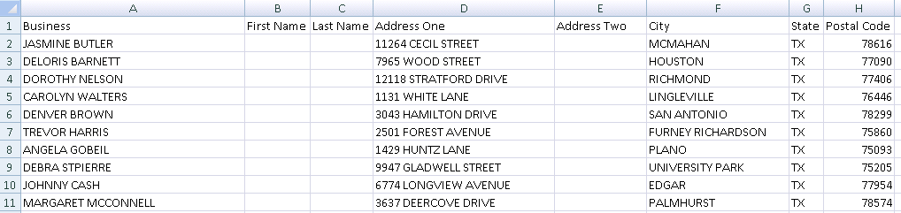

Create Excel email list: This produces an Excel spreadsheet of the email addresses for members of the campaign. This spreadsheet could be used to create a mailing to the members.

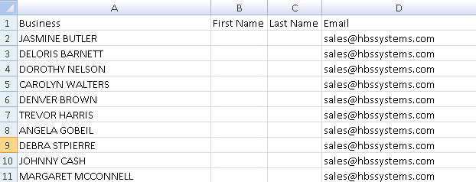

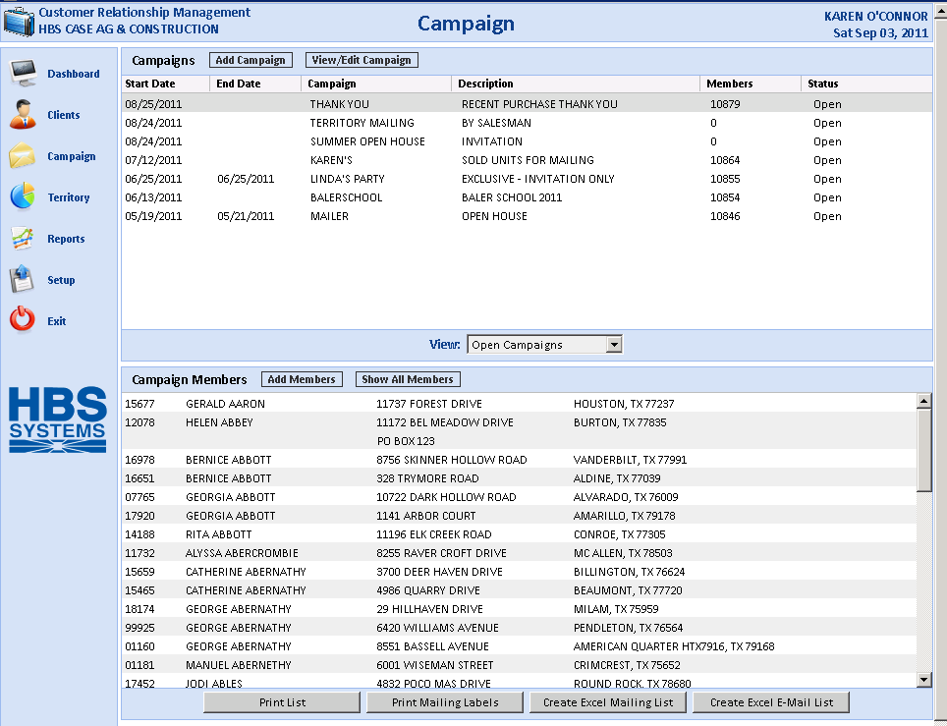

From the main campaign screen, you can also view Open or Closed campaigns by selecting one from the drop-down menu in the middle of the screen.

Campaign Members: From this screen you can add members to the campaign or show all members available.

Add members to a campaign

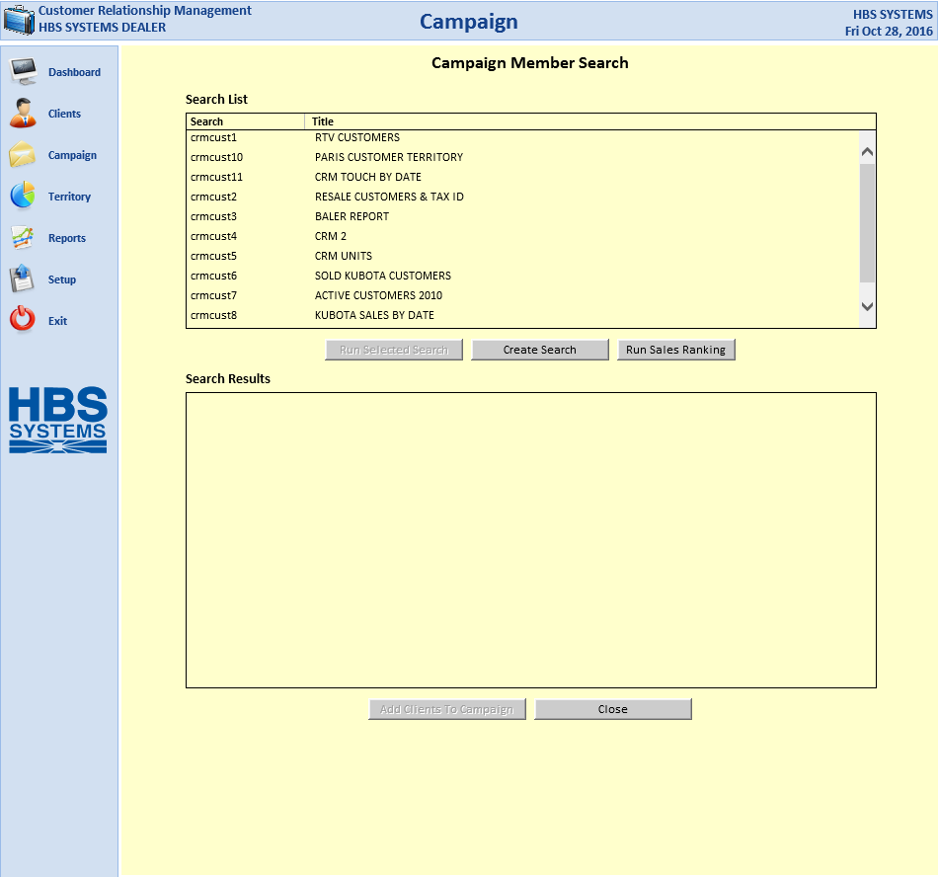

When adding members to a campaign, you can search for particular customers by either:

- Using an existing search shown.
- Creating a new search. NOTE: When you create a new search, you will be directed to Report Writer (RW) to build the selection criteria for that search.

The search results for a new or existing search appear in the bottom panel of the screen. You can then choose to add the results of the search to your campaign.

You can also get a list of clients by Sales Ranking to aid your selection process by clicking Run Sales Ranking. This opens the Customer Sales Ranking (CSR) report, which can generate the list based on entered criteria.

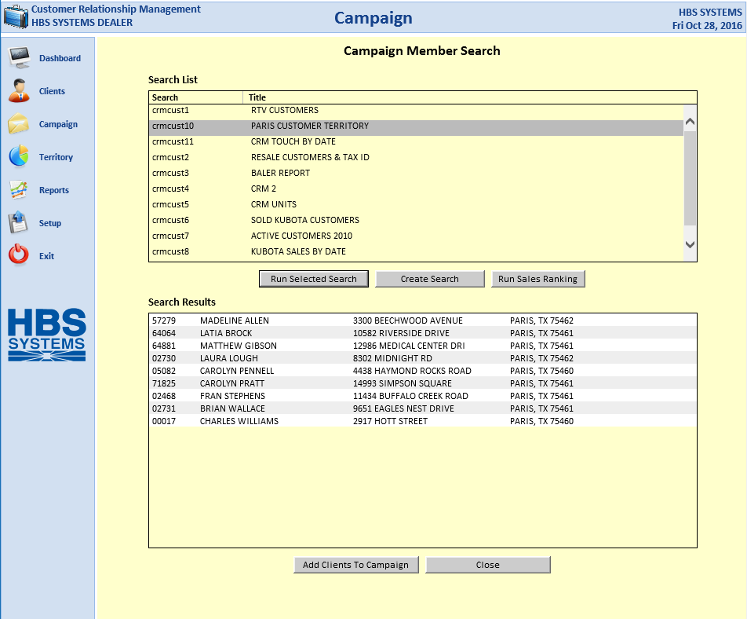

When you create a new search or use an existing one, the members that match the criteria are displayed in the lower portion of the screen. At that point you may click the Add Clients to Campaign button and include them on the campaign.

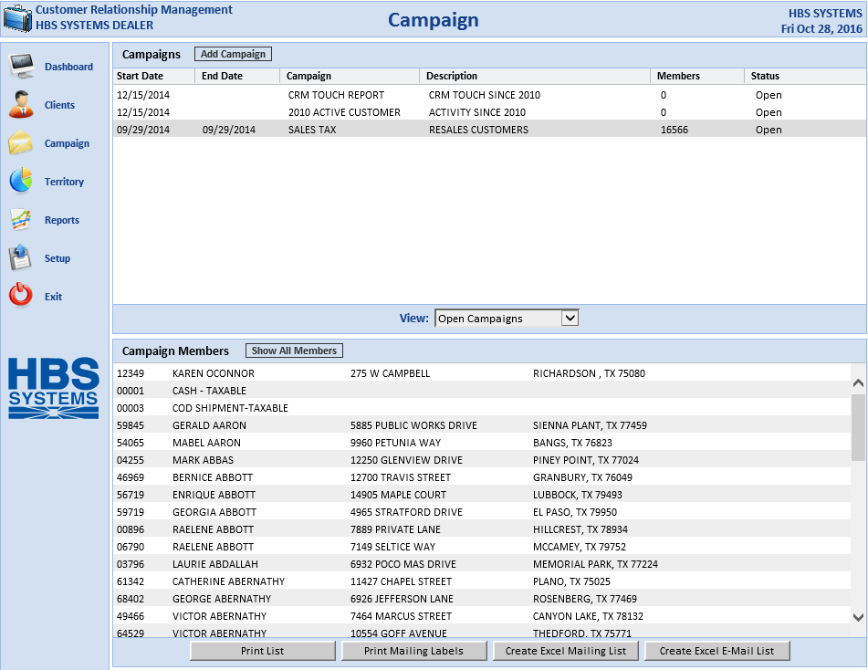

The newly selected members now show in the Campaign Members panel on the screen.

Add a Campaign: Click on the Add Campaign button to create a new campaign.

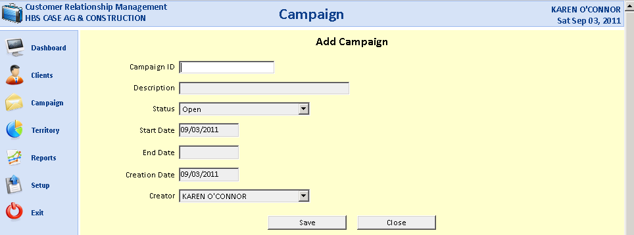

Campaign ID: Enter a name for your campaign.

Description: Provide a brief description of the campaign.

Status: Indicate if the campaign is:
- Open
- Closed

Start Date: Enter the starting date for the campaign.

Enter Date: Enter the ending date for the campaign.

Creation Date: Today's date will pre-fill for the date the campaign was created, but you may change it as needed.

Creator: Your login/salesman ID will pre-fill here, but can be changed as needed.

When you press the Save button, the new campaign will be added to the list of existing campaigns.

